**M.L. - Terminologies**

**Training-set:** Data used to train a model

* + - In a training set, the input is denoted by ‘x’ and it is also known as ‘feature’ and the output is denoted by ‘y’ and is known as ‘target’.
    - ‘m’ is used to denote the total number of training examples.
    - (x, y) is used to denote a single record in the training set.
    - (x(i), y(i)) is used to denote the ith record in the training set i.e., ith training example.
    - ‘ŷ’ is the estimate value of ‘y’ as predicted by the regression model and may or may not be equal to the true value of ‘y’ at the same ‘x’ according to the data set.

Machine Learning is of two types:

* **Supervised Learning**

In supervised learning the learning algorithm is provided with the “right answers” to any input ‘x’, to train the model by giving it data.

The model is provided with the mapping of ‘x’ to a particular ‘y’ value.

* + - **Regression:** When a learning algorithm is used to predict a number from many options (infinitely many), it is known as regression.

* + - **Classification:** When a learning algorithm only has a finite (usually two) options to choose the output from (like 0 / 1), it is known as classification. E.g.: If there is a defect in a product during visual inspection of the product just off the assembly line.
* **Unsupervised Learning**

In unsupervised learning the model is provided with the dataset of only inputs i.e., ‘x’ and not provided with the “right answers”, hence the model is unsupervised and has to decide for itself what is a “right answer” in any scenario.

The algorithm hence must find a structure in the data itself.

* + - **Clustering algorithm:** It is a type of unsupervised learning algorithm which tries to form clusters of the various groups of unorganized datasets which are presented to it as input and then tries to predict the nature of the dataset.

* + - **Anomaly Detection:**
    - **Dimensionality Reduction:**

**Linear regression:**

In this supervised learning algorithm, the algorithm plots a line at an average position using the dataset and then tries to predict a number from an infinitely large number list.

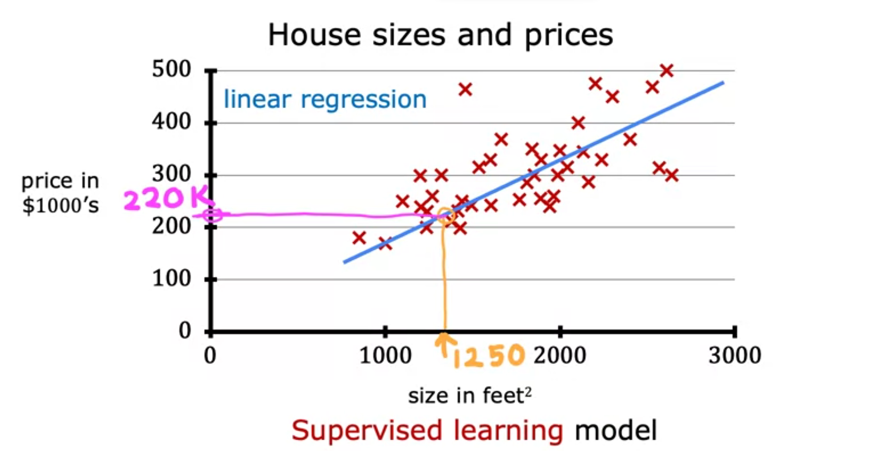

In a linear regression model, the training set (features and targets) are fed into the learning algorithm and the algorithm in turn returns to us a function (usually called a hypothesis) which later can be applied to predict the nature of ‘y’ at different values of ‘x’.

The function as returned by the linear regression model is a function of ‘x’ and returns ‘ŷ‘ as output.

It can be represented by the equation of a straight line.

, where w: weight & b: bias

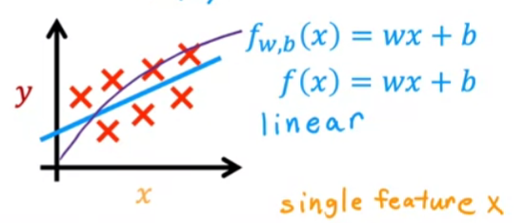

Linear regression model with just one feature variable is known as a “LINEAR REGRESSION MODEL WITH ONE VARIABLE” or a “UNIVARIATE LINEAR REGRESSION MODEL”.